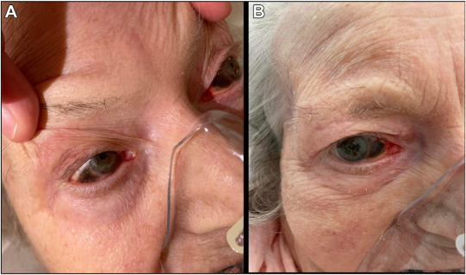

An 88-year-old woman with carcinomatosis and leukemoid reaction presented with a rare case of "taches noir de la sclerotique." Recentstudies have challenged the belief that this phenomenon is strictly postmortem and suggest an association with prolonged eye exposure. Thedistinctive triangular pattern appeared across the sclera hours before the patient’s demise (A, B), suggesting that blinking cessation due toterminal disease may have contributed to this manifestation, in line with recent research. Lubricating eye care was administered, but sadly,the patient passed away. This unconventional timeline emphasizes the need for increased clinical awareness and further exploration of thepathophysiology of "tache noir de la sclerotique." Based on the provided images and clinical description please make an ophthalmic diagnosis for this patient. And output the diagnostic conclusions only.

**Diagnostic Conclusion:  
The patient presents with "tache noire de la sclérotique", a rare ocular finding typically associated with postmortem changes but observed antemortem in this case. The triangular dark discoloration on the sclera, especially in the interpalpebral zone, is consistent with exposure keratopathy/scleropathy due to incomplete blinking or eye closure, often seen in terminally ill patients. This supports the hypothesis that prolonged ocular exposure and desiccation can lead to these scleral changes before death.**